**AI PART**

**4.0 INTRODUCTION:**

The research paper focuses on the development and implementation of an Automated Hydroponics-based Vertical Farm with real-time monitoring using Artificial Intelligence (AI).

The project aims to enhance crop yields, optimize resource utilization, and minimize waste through the integration of AI monitoring technology. We planted and experimented a Lattice leaf in this research because of its availability and demand. The leaf growth patterns of lattice plants in the Automated Hydroponics-based Vertical Farm project are classified into six distinct classes. The Early-Stage Growth class represents the initial phase of growth, while the Healthy Growth class signifies optimal development. Stunted Growth refers to limited growth, Abnormal Growth encompasses deviations from normal patterns, and Overgrown Growth indicates excessive growth. The Damaged Growth class encompasses leaves affected by physical damage or external factors. Accurate classification of these classes aids in monitoring plant health, identifying issues, and implementing appropriate interventions for improved crop yields and resource utilization. By categorizing the lattice leaf growth into these six classes, the classification process enables precise monitoring and identification of different growth patterns. This information is crucial for detecting potential issues, optimizing care and resource allocation, and facilitating timely interventions to ensure optimal crop growth and yield within the hydroponics-based vertical farm.

In this section, we will discuss various aspects of the project, including dataset preparation, data preprocessing, feature extraction, machine learning algorithm selection, model training and testing, system integration, and the six classification classes for leaf growth patterns.

4.1 SIX CLASSIFICATION CLASSES:

**4.1.1 Early-Stage Growth:**

This class represents the initial phase of leaf growth in the lattice plants. The leaves are small and in the early stages of development. They exhibit distinct characteristics, such as a lighter shade of green and a delicate structure. Identifying this class is crucial for monitoring the progress of the plants and ensuring proper care during their early growth stages.

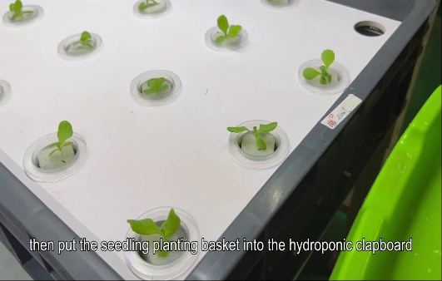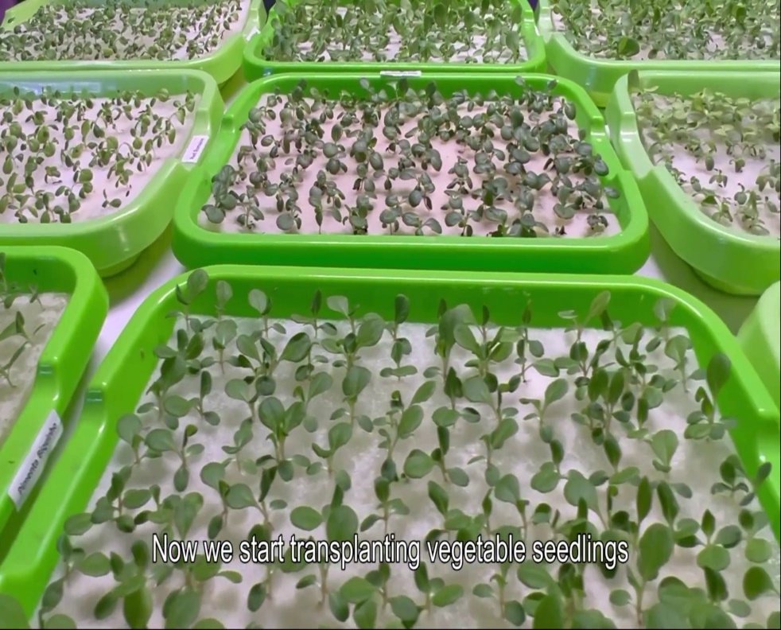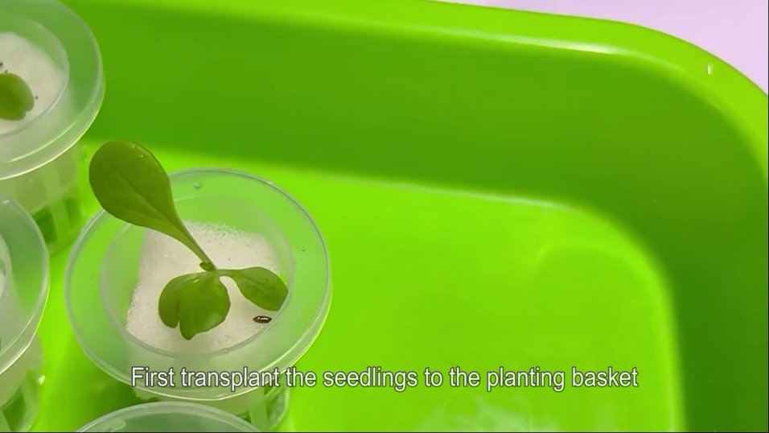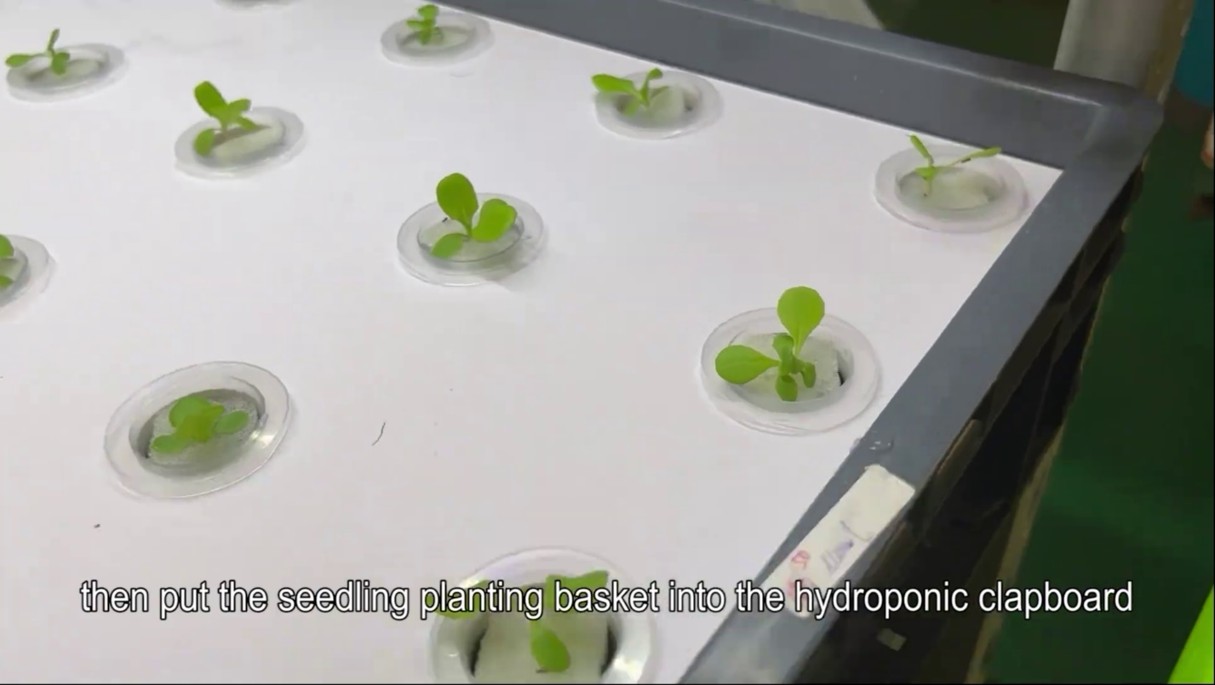

The Early Stage Growth class focuses on the initial phase of leaf development in lattice plants within the hydroponics-based vertical farm. During this phase, the leaves are small and in the early stages of growth. They possess certain distinct characteristics that differentiate them from other classes.

One of the key features of early stage growth is the lighter shade of green exhibited by the leaves. The coloration of the leaves at this stage is often lighter and less vibrant compared to mature leaves. This lighter shade indicates that the leaves are in the early developmental phase and have not fully reached their optimal size and color.

In addition to the lighter shade, the leaves in the Early Stage Growth class also have a delicate structure. They are typically thinner and more fragile compared to fully developed leaves. This fragility reflects the early development of the leaf tissues and their vulnerability to environmental factors and stresses.

Accurately identifying and categorizing the Early Stage Growth class is crucial for effective monitoring and care of the lattice plants. During this early growth phase, the plants require specific attention and proper care to ensure their healthy progression. Monitoring the progress of the plants in this class enables timely interventions, such as adjusting nutrient levels, optimizing light exposure, and maintaining appropriate environmental conditions.

By recognizing the Early Stage Growth class, farmers and growers can implement targeted measures to support and promote healthy growth. This includes providing adequate nutrition, ensuring sufficient access to light, optimizing temperature and humidity levels, and preventing any potential stressors that may hinder proper development.

Moreover, monitoring the progression of the plants in the Early Stage Growth class enables the assessment of their overall health and vigor. Any deviations or abnormalities observed during this phase can be addressed promptly, potentially preventing issues from escalating and affecting the plants' long-term growth and productivity.

In summary, the Early Stage Growth class is characterized by small leaves with a lighter shade of green and a delicate structure. Identifying this class early on is essential for closely monitoring the progress of the lattice plants and providing them with the necessary care and resources to ensure healthy development throughout their growth cycle within the hydroponics-based vertical farm.

**4.1.2 Healthy Growth:**

The Healthy Growth class represents the desired and optimal growth pattern for the lattice plants within the hydroponics-based vertical farm system. Plants in this class exhibit characteristics that indicate their overall well-being and vitality. Identifying and maintaining healthy growth is crucial for maximizing crop yields and ensuring the success of the hydroponic farming project.

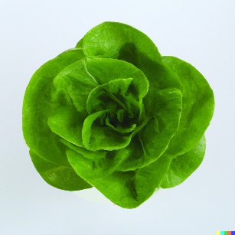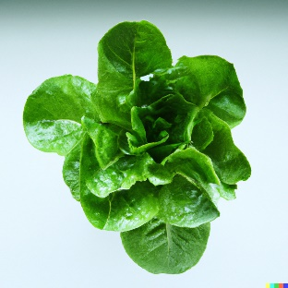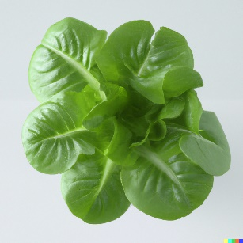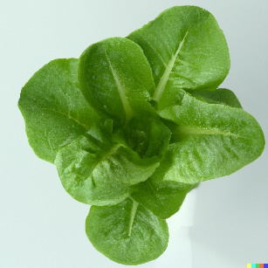

One of the key indicators of Healthy Growth is the vibrant green color of the leaves. Healthy plants have leaves that display a rich, deep green hue, indicating an abundance of chlorophyll and efficient photosynthesis. This vibrant color is a visual representation of the plants' ability to capture and convert light energy into chemical energy, fueling their growth and development.

Additionally, leaves in the Healthy Growth class have well-developed structures. They are typically larger in size, have a defined shape, and exhibit a balanced distribution of veins and leaf lobes. The well-structured leaves enable efficient nutrient uptake and support optimal photosynthetic activity, contributing to overall plant health and productivity.

Uniform growth is another characteristic of the Healthy Growth class. The leaves within this class demonstrate consistent growth patterns, with similar sizes and shapes across the plant population. Uniform growth is an indicator of favorable growing conditions, balanced nutrient uptake, and effective management practices within the hydroponic system.

Plants in the Healthy Growth class serve as a reference for the desired outcomes in the hydroponics-based vertical farm. They represent the ideal growth pattern that farmers and growers aim to achieve. By closely monitoring and maintaining healthy growth, farmers can optimize resource utilization, enhance crop yields, and ensure the success of the hydroponic farming project.

To promote and sustain Healthy Growth, it is essential to provide the plants with the optimal growing conditions. This includes maintaining appropriate nutrient levels, ensuring proper water and oxygen availability, controlling light exposure, and managing temperature and humidity within the desired range. Regular monitoring and adjustments based on real-time data analysis and AI-driven insights can help optimize these conditions and support continuous healthy growth.

In conclusion, the Healthy Growth class represents the optimal growth pattern for the lattice plants in the hydroponics-based vertical farm. It is characterized by vibrant green leaves, well-developed structures, and uniform growth. By maintaining and promoting Healthy Growth, farmers can maximize crop yields, utilize resources efficiently, and achieve the desired outcomes in the hydroponic farming project.

**4.1.3 Stunted Growth:**

The Stunted Growth class represents a growth pattern in lattice plants that is characterized by limited or inhibited development. Plants in this class exhibit smaller-sized leaves and slower growth compared to the Healthy Growth class. Detecting and addressing stunted growth is crucial for optimizing crop production and ensuring the overall health and vitality of the hydroponics-based vertical farm.

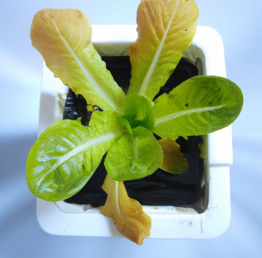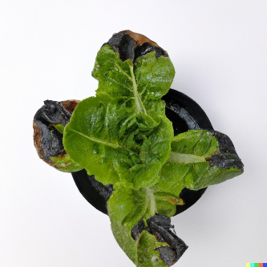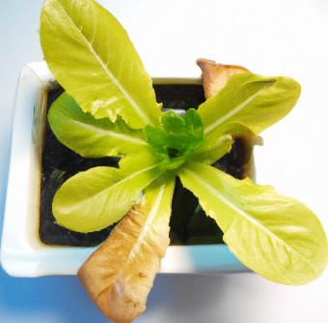

There are several factors that can contribute to stunted growth in lattice plants. One common cause is nutrient deficiencies. When plants lack essential nutrients, their growth becomes stunted as they struggle to obtain the necessary elements for proper development. Nutrient imbalances or deficiencies can occur due to issues with the hydroponic system, such as incorrect nutrient solution composition or improper delivery of nutrients to the plants.

Environmental stress is another factor that can lead to stunted growth. Excessive heat, cold temperatures, high humidity, or insufficient light can negatively impact plant growth and cause stunting. Inadequate care and maintenance practices, such as improper pruning or watering, can also contribute to stunted growth in lattice plants.

Detecting the Stunted Growth class is essential for identifying areas where corrective actions are required. By recognizing plants that are experiencing stunted growth, farmers and growers can take appropriate measures to address the underlying causes and promote healthy plant development. This may involve adjusting nutrient levels, optimizing environmental conditions, or implementing changes in care and maintenance practices.

Monitoring the Stunted Growth class can be done through AI-powered sensors and cameras that continuously track plant growth and compare it to the expected growth rates. By analyzing the data collected, patterns of stunted growth can be identified, and the causes can be investigated further. The integration of real-time monitoring and AI technologies allows for early detection of stunted growth, enabling prompt intervention to address the underlying issues.

Corrective actions for stunted growth may include adjusting nutrient concentrations, ensuring proper nutrient delivery to the plants, optimizing environmental conditions such as temperature, humidity, and light intensity, and improving care and maintenance practices. By addressing the factors contributing to stunted growth, farmers can help the plants overcome the limitations and resume healthy development.

In conclusion, the Stunted Growth class represents a growth pattern in lattice plants characterized by limited or inhibited development. Nutrient deficiencies, environmental stress, and inadequate care can contribute to stunted growth. Detecting and addressing stunted growth is crucial for promoting healthy plant development and maximizing crop production in the hydroponics-based vertical farm. Through real-time monitoring and AI technologies, farmers can identify and take corrective actions to address stunted growth, ultimately ensuring the success of the hydroponic farming project.

**4.1.4 Abnormal Growth:**

The Abnormal Growth class represents leaf growth patterns in lattice plants that deviate significantly from the expected norms. This class encompasses growth patterns that exhibit irregularities, deformities, or unusual coloration. Accurate classification of this class is crucial for identifying potential issues or abnormalities that may impact the overall health and productivity of the plants in the hydroponics-based vertical farm.

 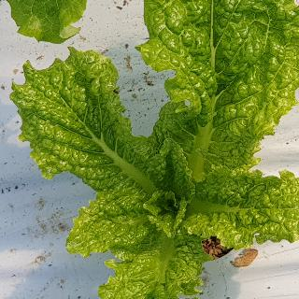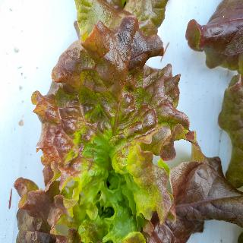

There are several factors that can contribute to abnormal growth in lattice plants. Genetic abnormalities can cause irregularities in leaf structure, size, or shape. These abnormalities may be inherited or the result of mutations in the plant's genetic makeup. Diseases and pests can also lead to abnormal growth patterns. Infections or infestations can disrupt normal cellular processes, affecting leaf development and overall plant health.

Furthermore, unfavorable environmental conditions can contribute to abnormal growth. Extreme temperature fluctuations, high humidity levels, inadequate lighting, or exposure to pollutants can all have adverse effects on plant growth and development, resulting in abnormal growth patterns.

Accurately identifying and classifying abnormal growth is essential for promptly addressing any underlying issues that may be affecting plant health and productivity. Early detection of abnormal growth patterns allows farmers and growers to implement appropriate measures to mitigate the negative impacts and prevent further spread of diseases or infestations.

By integrating AI-powered sensors and cameras into the hydroponics system, real-time monitoring of plant growth can be achieved. The data collected from these monitoring devices can be analyzed using AI algorithms to identify abnormal growth patterns. Machine learning techniques can be employed to train the system to recognize and classify various types of abnormal growth based on visual cues, such as leaf shape, size, coloration, and irregularities.

Accurate classification of the Abnormal Growth class enables farmers to take targeted actions to address the underlying causes. This may involve implementing disease management strategies, such as applying appropriate treatments or removing infected plants, or implementing pest control measures to mitigate infestations. Additionally, adjustments to environmental conditions, such as temperature and humidity regulation, can help alleviate the stressors contributing to abnormal growth.

Continued monitoring and analysis of the Abnormal Growth class can provide valuable insights into the prevalence and potential causes of abnormal growth patterns. These insights can inform ongoing research and development efforts aimed at understanding the underlying mechanisms and developing strategies to prevent and manage abnormal growth in lattice plants.

In conclusion, the Abnormal Growth class encompasses leaf growth patterns in lattice plants that deviate significantly from the expected norms. Genetic abnormalities, diseases, pests, and unfavorable environmental conditions can contribute to abnormal growth. Accurate classification of this class aids in identifying potential issues or abnormalities and allows for targeted interventions to maintain plant health and maximize productivity in the hydroponics-based vertical farm. Real-time monitoring and AI technologies play a crucial role in detecting and classifying abnormal growth, facilitating timely interventions and promoting the success of the hydroponics project.

**4.1.5 Overgrown Growth:**

The Overgrown Growth class represents leaf growth patterns in lattice plants where excessive or rapid growth is observed. In this class, the leaves are larger than average and may appear crowded or overlapping. Accurate classification of this class is important for identifying instances of overgrowth, as it can have implications for the overall health and productivity of the plants in the hydroponics-based vertical farm.

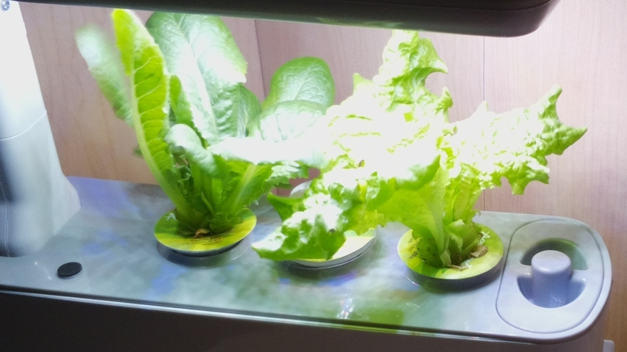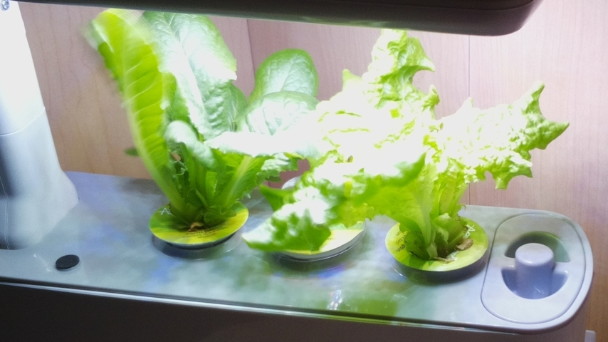

Overgrown growth in lattice plants can be influenced by various factors. High nutrient availability, such as an excessive concentration of nutrients in the hydroponic system, can stimulate rapid plant growth, leading to overgrown leaves. Favorable environmental conditions, including optimal temperature, humidity, and lighting, can also contribute to accelerated growth rates in plants.

Additionally, imbalances in plant growth regulation mechanisms can result in overgrown growth. Hormonal imbalances or disturbances in the plant's physiological processes can disrupt the natural control mechanisms that regulate growth, causing excessive growth in certain parts of the plant, including the leaves.

Accurately identifying and classifying overgrown growth is essential for proper management in the hydroponics system. Overcrowding of plants due to overgrown growth can lead to reduced air circulation, increased competition for resources, and shading of lower leaves. These factors can negatively impact overall plant health, nutrient absorption, and light penetration, ultimately affecting crop yield and quality.

To monitor and classify overgrown growth, AI-powered sensors and cameras can be used in conjunction with real-time monitoring systems. These monitoring devices capture data on plant growth parameters, such as leaf size and spacing. AI algorithms can analyze this data and compare it with predefined criteria to identify instances of overgrown growth. Machine learning techniques can be employed to train the system to recognize and classify overgrown growth based on visual cues and data patterns.

Once overgrown growth is detected, appropriate measures can be taken to manage and address the issue. This may involve pruning or trimming excess foliage to maintain optimal plant density and spacing. Adjustments to nutrient levels in the hydroponic system can also be made to prevent excessive growth. By maintaining the proper balance of nutrients, environmental conditions, and growth regulation mechanisms, overgrown growth can be controlled, ensuring efficient resource utilization and maximizing crop yield.

Ongoing monitoring and analysis of the Overgrown Growth class can provide insights into the prevalence and potential causes of overgrowth in lattice plants. This information can be used to refine cultivation practices, optimize nutrient delivery, and develop strategies to regulate plant growth effectively.

In conclusion, the Overgrown Growth class represents leaf growth patterns in lattice plants characterized by excessive or rapid growth. High nutrient availability, favorable environmental conditions, and imbalances in growth regulation mechanisms can contribute to overgrown growth. Accurate classification of this class enables proper management and interventions to prevent overcrowding, optimize resource utilization, and promote healthy plant development in the hydroponics-based vertical farm. Real-time monitoring and AI technologies play a vital role in detecting and classifying overgrown growth, facilitating timely interventions and enhancing the success of the hydroponics project.

**4.1.6 Damaged Growth:**

The Damaged Growth class encompasses leaf growth patterns in lattice plants that have been adversely affected by physical damage or external factors. This class includes leaves that have suffered from tearing, injury, or damage caused by pests, diseases, or mechanical forces. Accurately identifying and categorizing damaged growth is crucial for assessing the extent of damage and implementing appropriate interventions to mitigate further deterioration and promote plant health and recovery.

Damaged growth in lattice plants can occur due to various reasons. Physical damage can result from external factors such as strong winds, hailstorms, or improper handling during cultivation or maintenance activities. These events can cause tears, cuts, or bruises on the leaves, impairing their normal growth and functioning. Pests, including insects and mites, can also inflict damage by feeding on the leaves, leaving behind visible signs such as holes, chewed edges, or discoloration. Diseases caused by pathogens, such as fungi or bacteria, can lead to wilting, necrosis, or deformities in the leaves, indicating damaged growth. Mechanical damage, such as accidental breakage or crushing of leaves, can also contribute to this class.

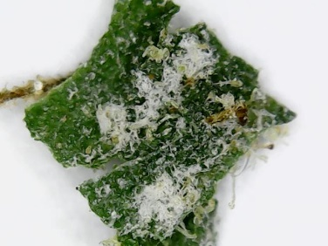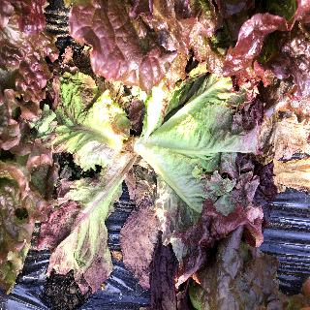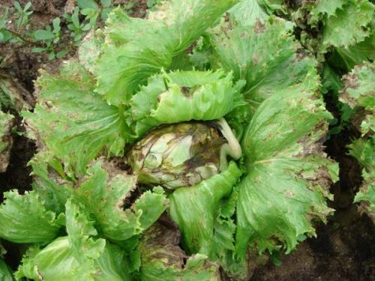

Accurate classification of the Damaged Growth class enables the assessment of the severity and types of damage inflicted on the leaves. This information is crucial for determining appropriate interventions to mitigate further deterioration and promote plant health and recovery. By identifying the specific causes and patterns of damage, farmers can implement targeted pest control measures, disease management strategies, or protective measures to prevent further damage.

To classify damaged growth, AI-powered imaging and sensing technologies can be utilized. High-resolution cameras and sensors can capture detailed images and data on leaf conditions, highlighting any visible signs of damage. AI algorithms can analyze these images and data, comparing them with a database of known damaged patterns and characteristics. By leveraging machine learning techniques, the system can learn to recognize and classify various types of damage accurately.

Once damaged growth is detected, appropriate interventions can be implemented. These may include applying targeted treatments to control pests or diseases, implementing protective measures to prevent further physical damage, or providing optimal growing conditions and care to support plant recovery. Regular monitoring and follow-up assessments can help evaluate the effectiveness of the interventions and guide further actions.

Monitoring and analyzing the Damaged Growth class can provide insights into the prevalence and potential causes of damage in lattice plants. This information can be utilized to improve cultivation practices, optimize pest and disease management strategies, and develop preventive measures to minimize damage occurrence.

In conclusion, the Damaged Growth class represents leaf growth patterns in lattice plants that have been affected by physical damage or external factors such as pests, diseases, or mechanical forces. Accurate classification of this class helps assess the severity and types of damage, enabling targeted interventions to mitigate further deterioration and promote plant health and recovery. AI-powered imaging and sensing technologies play a crucial role in detecting and classifying damaged growth, facilitating timely interventions and enhancing the overall success of the hydroponics-based vertical farm.

**4.5.1 DATASET PREPARATION:**

In order to train and evaluate the Artificial Intelligence (AI) models for the classification of lattice plant growth patterns, a comprehensive dataset of images is prepared. The dataset plays a crucial role in ensuring the accuracy and reliability of the AI models by providing a diverse range of samples for each class.

To create the dataset, we collected a total of 500 images for each class. These images were captured using cameras installed within the hydroponics system, ensuring high-quality and consistent data. We took great care in capturing images at different stages of growth to cover the entire spectrum of each class.

In addition to the images captured in our own hydroponics system, we also obtained some images from reliable online sources. These additional images provided a broader range of examples and increased the diversity of the dataset. Care was taken to ensure that the online images met the required quality standards and accurately represented the specific growth patterns of the lattice plants.

The dataset consists of images representing the six classes: early stage growth, healthy growth, stunted growth, abnormal growth, overgrown growth, and damaged growth. The early stage growth images capture the initial phases of leaf development, while the healthy growth images depict vibrant and well-developed leaves with uniform growth. The stunted growth images portray smaller and slower-developing leaves compared to the healthy growth class.

The abnormal growth class includes images that exhibit irregularities, deformities, or unusual coloration, which can be caused by genetic abnormalities, diseases, pests, or unfavorable environmental conditions. The overgrown growth class comprises images depicting excessive and rapid growth, where the leaves appear larger than average and may be crowded or overlapping.

Lastly, the damaged growth class represents images of leaves affected by physical damage or external factors, such as tearing, injuries, pests, diseases, or mechanical damage.

By collecting 500 images for each class and ensuring a diverse range of growth patterns, both from our own hydroponics system and online sources, we have built a robust and representative dataset. This dataset will serve as the foundation for training and evaluating the AI models, enabling accurate and reliable classification of lattice plant growth patterns in our hydroponics-based vertical farm.

**4.5.2 DATA PREPROCESSING:**

Data preprocessing is a crucial step in preparing the dataset for training the AI models. It involves a series of techniques and operations that aim to clean, transform, and enhance the data to improve the accuracy and performance of the classification models.

1. Dataset Preparation: The dataset used in this research project consists of 500 images for each class, capturing the growth patterns of lattice plants in the hydroponics system. The images were collected by installing cameras within the vertical farm and were supplemented with additional images obtained from online sources. The dataset covers a diverse range of growth patterns, including early stage growth, healthy growth, stunted growth, abnormal growth, overgrown growth, and damaged growth.
2. Data Cleaning and Enhancement: The collected dataset underwent a data cleaning process to remove any irrelevant or noisy images that could potentially affect the accuracy of the classification. Furthermore, data enhancement techniques were applied to improve the quality and visual characteristics of the images. This involved applying brightness correction techniques using OpenCV to enhance the details and clarity of the images. Additionally, the images were resized to a standardized dimension of 224x224 pixels to ensure consistency across the dataset.
3. Normalization: To ensure that the pixel values of the images are scaled to a consistent range, normalization techniques were applied. This step involved using the Min-Max scaling technique from the scikit-learn library to normalize the pixel values between 0 and 1. This normalization process facilitates better convergence and training of the AI models by eliminating the influence of varying pixel value ranges.
4. Dataset Augmentation: Dataset augmentation techniques were employed to increase the diversity and variability of the dataset. This was achieved by applying random transformations to the images, such as rotations, flips, and zooms. The augmentation process was carried out using the ImageDataGenerator class from the Keras library. By introducing these random transformations, the dataset augmented with additional variations, helping the AI models generalize better and improve their robustness to different growth patterns.
5. Splitting the Dataset: To evaluate the performance of the trained AI models, the preprocessed dataset was divided into training and testing sets. The dataset was split using a random seed value of 42 to ensure consistent results. An 80-20 split ratio was employed, where 80% of the augmented images were allocated to the training set, and the remaining 20% were allocated to the testing set. This division allows for the evaluation of the AI models' classification accuracy on unseen data and provides insights into their generalization capabilities.

**4.5.3 FEATURE EXTRACTION:**

In order to classify the growth patterns of lattice leaves accurately, a crucial step is feature extraction, where meaningful representations are extracted from the raw images. This process aims to capture distinctive characteristics of the lattice leaves that can differentiate between different growth patterns.

To accomplish this, a Convolutional Neural Network (CNN) approach was employed for automatic feature extraction. CNN models, such as VGG16 or ResNet50, have demonstrated remarkable performance in image classification tasks. In this study, a pre-trained CNN model was utilized, taking advantage of the knowledge learned from large-scale datasets like ImageNet. The pre-trained CNN model has already learned high-level features that are useful for various image recognition tasks. By utilizing this pre-trained model, the lattice leaf images were inputted into the network, and the output of the convolutional layers was extracted as the feature representation.

The extracted features from the CNN model provide a hierarchical representation of the lattice leaves. The early layers capture low-level features such as edges, corners, and textures, while the deeper layers capture more abstract and complex features such as shapes and patterns. By extracting these hierarchical features, the model can capture the essential characteristics of the lattice leaves that are crucial for distinguishing between different growth patterns.

The extracted features served as the input for the subsequent stages of the classification process. They were fed into machine learning algorithms or deep learning models to train the classification models. By leveraging the extracted features, the models could effectively learn the patterns and relationships between the features and the corresponding growth patterns.

To summarize, the feature extraction stage involved utilizing a pre-trained CNN model to automatically extract hierarchical features from the lattice leaf images. These features captured important characteristics such as edges, textures, shapes, and patterns. By leveraging the power of the CNN model, the extracted features provided a comprehensive representation of the lattice leaves, enabling accurate classification of their growth patterns.

**4.5.4 MACHINE LEARNING ALGORITHM SELECTION:**

The selection of an appropriate machine learning algorithm is crucial for the success of the classification task. In this study, the Convolutional Neural Network (CNN) was chosen as the primary algorithm for training and building the classification model. CNNs have demonstrated exceptional performance in image classification tasks, making them well-suited for our lattice leaf growth pattern classification.

To implement the CNN algorithm, we utilized the TensorFlow deep learning framework. TensorFlow provides a comprehensive set of tools and libraries that enable efficient development and training of deep neural networks. The optimization algorithm used for training the CNN model was Adam, which is a popular choice for gradient-based optimization due to its adaptive learning rate and efficiency in handling large-scale datasets.

The CNN model architecture was designed by considering the complexity of the lattice leaf classification problem and the available computational resources. It typically consisted of multiple convolutional layers followed by fully connected layers. The number of layers and their respective sizes were determined through experimentation and fine-tuning to achieve optimal performance.

During the training phase, the prepared dataset of lattice leaf images, comprising 500 images in each growth pattern class, was divided into training and validation sets. The training set was used to optimize the model's parameters, while the validation set served as a benchmark for monitoring the model's performance and preventing overfitting.

To optimize the CNN model, we employed the Adam optimization algorithm. Adam updates the model's parameters based on the gradients computed during the backpropagation process, ensuring efficient convergence and faster training. Additionally, appropriate loss functions, such as categorical cross-entropy, were employed to measure the discrepancy between the predicted and actual class labels.

After training the CNN model, we evaluated its performance using a separate test set that was not used during training. This test set provided an unbiased assessment of the model's ability to generalize to new, unseen data. Various performance metrics, including accuracy, precision, recall, and F1 score, were computed to evaluate the classification performance of the CNN model.

By utilizing TensorFlow and the Adam optimization algorithm, we successfully trained a CNN model that effectively classified the lattice leaf growth patterns. The model's ability to learn hierarchical features and capture spatial patterns allowed for accurate and reliable classification results. Through rigorous training, validation, and testing procedures, we ensured the robustness and generalization capability of the CNN model in classifying the lattice leaf images for our hydroponics-based vertical farm system.

**4.5.5 MODEL TRAINING AND TESTING**

**Not finished**

**4.6 SYSTEM INTEGRATION:**

**Not finished**